**Predictive Modeling Logistic Regression**

**Part I: Research Question**

A research question that would assist any health organization to reduce cost and better prepare would be to help identify factors that cause medical beneficiaries to readmit themselves back into a hospital. The objectives would be to identify key factors that contribute to people having readmit themselves into the hospital. For example, does the fact that someone is obese guarantee someone being readmitted into the hospital and if so then this would be a good component to look at when people are being assisted on their first visit.

**Part II: Method Justification**

The assumptions of logistic regression are that the dependent variable needs be binary. Meaning that the outcome needs to be a “Yes” or “No” or either a 0 or 1. Secondly the dependent variables need to be independent of one another. This means that one variable cannot be connected or attached to second variable. Third, there cannot be any multicollinearity amongst the variable. Python will be the preferred tool to use. This is because of its many robust packages such as sklearn and statsmodels. Both these packages are used for the majority of the heavy lifting. (Peter Bruce, 2020)

Logistic regression is the appropriate technique since our dependent variable will be Yes or No. Our dependent variable is ultimately trying to answer whether a person readmit into the hospital or not.

**Part III: Data Preparation**

The data preparation goals are to choose relevant variables to predict the outcome variable. Our dataset has 50 features that range from income to address. Eliminating all unnecessary variables will be the first step to prepare the data. Also, although we were informed that the data sheet was already clean, we will look for empty cells and outliers to make sure everything will work appropriately.

The target variable is labeled as “ReAdmis.” Out of the 10,000 rows, “No” makes up 6k of that amount. The two independent variables are “Initial_admin_Emergency Admission” and “Services_CT Scan. ” Initial admin is evenly distributed but Initial admin was leaning heavily weighted by No. Attached are screenshots of variables.

The steps taken to prepare the data for the model was to standardize the data completely. The data was heavily skewed by income information and the charges of the hospital visit and stay. Another step to prepare the model was to calculate the feature values of the model and remove all unnecessary values. (Gareth James, 2019) Attached is the code for reference:

Bivariate Displays

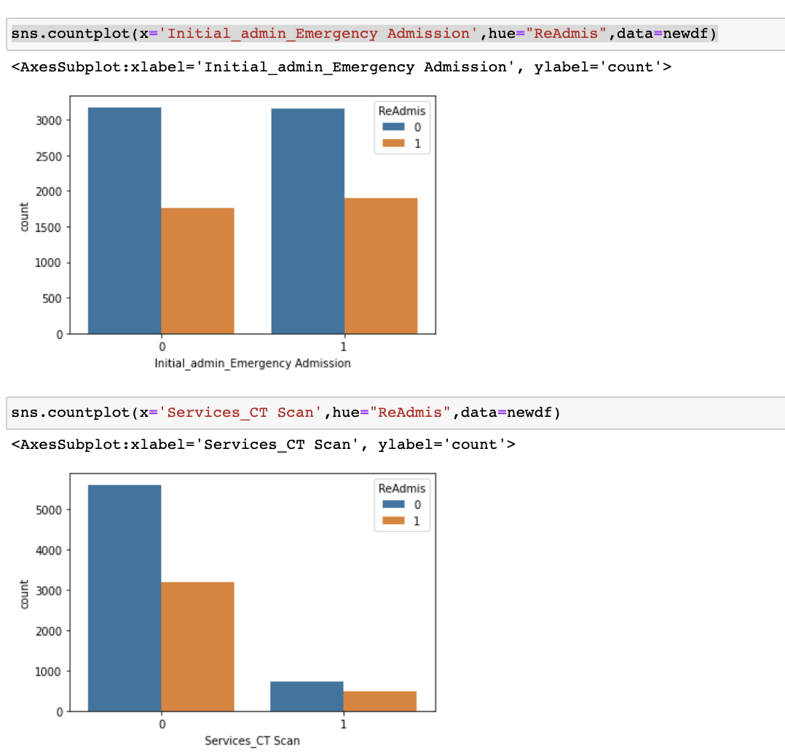

Univariate Displays

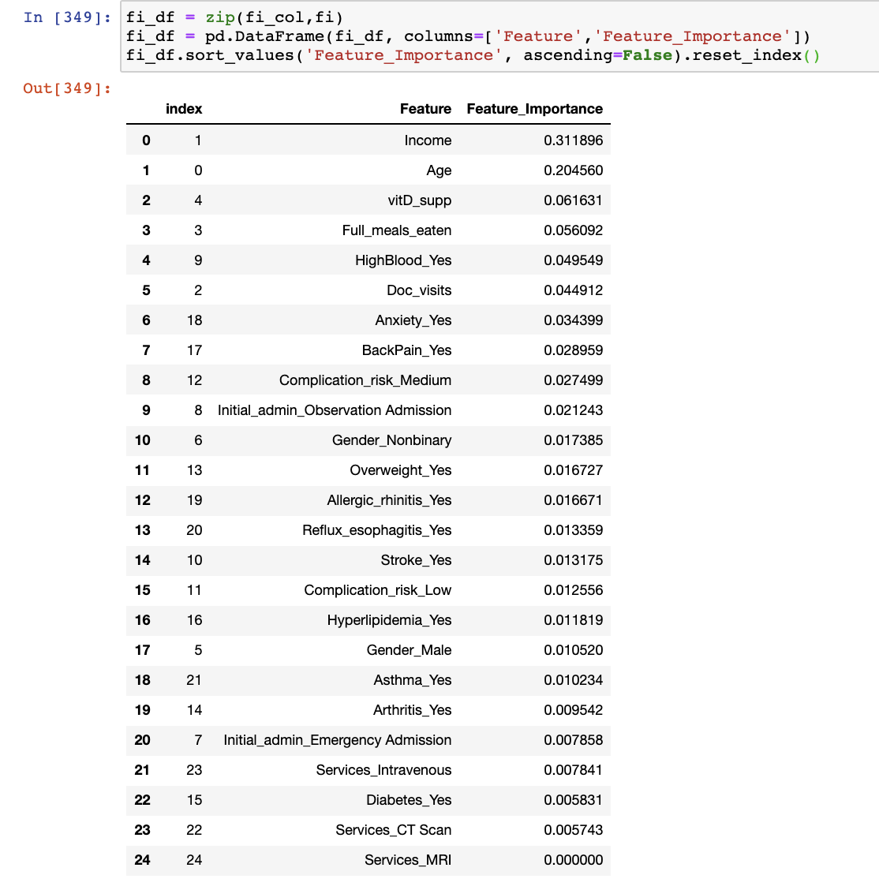

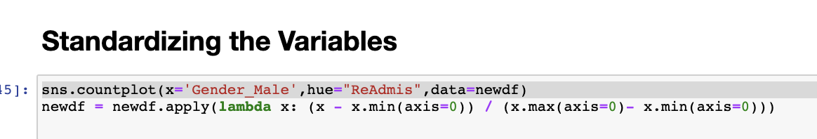

**Part IV: Model Comparison and Analysis**

The initial model contained all variables that did not consist of demographic information. Such as State, Country, and longitude and latitude variables. After the initial model was ran, all variables that had a high p-value were removed and, in the end, only two features were kept. Attached are screenshots of the models.

E.  Analyze the data set using your reduced logistic regression model by doing the following:

1.  Explain your data analysis process by comparing the initial and reduced logistic regression models, including the following elements:

•  the logic of the variable selection technique

•  the model evaluation metric

The output of both models is attached below. Both models performed above 60% but remained below 65%. Attached are screenshots of the confusion matrix for both models.

**Part V: Data Summary and Implications**

The formula for this model would be:

Y = -0.6057+.0811(Initial_admin_Emergency Admission)+0.1514(Services_CT Scan)

The coefficients show us that out of the two features that were targeted, Services_CT Scan carries the most weight. The statistical significance of the model shows us that out of the 50 variables that were in the initial dataset only two features were used to predict if a person would be readmitted into the hospital. The practical significance of this is that if we were to distribute this model to the hospital, it would benefit them to add liaison or staff to these two departments to help assist in the reduction of patients being readmitted. The best course of action would be to increase staff in these two departments for one year and then run the model again to see if there has been an improvement or we could analyze the hospitals information and check the reduction of readmitted patients.

# Bibliography

Gareth James, D. W. (2019). *An Introduction to Statistical Learning: with Applications in R .* Stanford: Springer Text.

Peter Bruce, A. B. (2020). *Practical statistics .* California: O'Reilly.